Market Research

The UK property industry has an estimated revenue of £11.1bn a year (Ibisworld.co.uk, 2018) with an annual growth of around 1%. It employs an estimated 158,619 members of staff through 20,823 businesses (Ibisworld.co.uk, 2018). Statistics show that there were approximately 51,000 estate agents and auctioneers in the UK in 2018 (Statista, 2018). The growth rate of the market may not be very attractive at only 1% but with an estimated revenue of £11.1bn 1% equates to a steady increase of £111m annually which is very attractive.

The below spreadsheet (fig 1) produced by HMRC shows that over 1.2 million residential properties with a value of £40,000 or higher had been sold in the UK up to November 2018 (Armstrong-Wood and Dickinson, 2018).



Research shows (fig 2) that on the 11th of January 2019 there are roughly 483,573 unique homes listed for sale online with a total value of £191 million across 4,423 property sales websites (home.co.uk, 2019). There are also 225,837 unique properties listed for rent across 3,104 websites.

However, the total number of properties listed for sale across websites that had been tracked was 5,694,583 showing that properties are listed with multiple estate agents. This highlights the need to create the property listings as quick as possible to gain the edge over your competitors

Combining the total number of sales and rental listings gives us a total market of 709,410 properties listed online through 20,823 businesses (Ibisworld.co.uk, 2018).

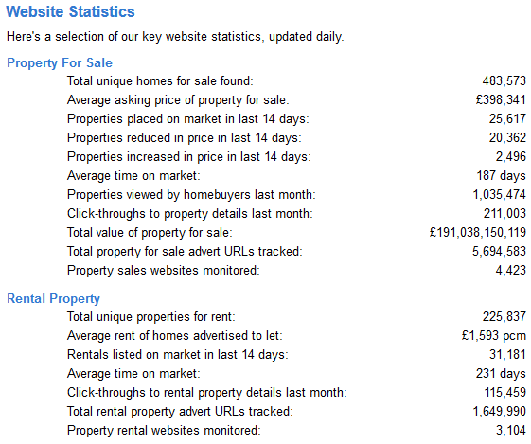

**Bibliography**

Armstrong-Wood, M. and Dickinson, M. (2018). *Monthly property transactions completed in the UK with value of £40,000 or above*. [online] GOV.UK. Available at: https://www.gov.uk/government/statistics/monthly-property-transactions-completed-in-the-uk-with-value-40000-or-above [Accessed 10 Jan. 2019].

home.co.uk. (2019). *Home.co.uk: Website Statistics*. [online] Available at: https://www.home.co.uk/company/stats.htm [Accessed 11 Jan. 2019].

Ibisworld.co.uk. (2018). *Estate Agents (UK) - Industry Research Reports | IBISWorld*. [online] Available at: https://www.ibisworld.co.uk/industry-trends/market-research-reports/real-estate-activities/estate-agents.html [Accessed 8 Jan. 2019].

Statista. (2018). *Estate agents & auctioneers 2011-2018 | UK Statistic*. [online] Available at: https://www.statista.com/statistics/319823/number-of-estate-agents-and-auctioneers-in-the-uk/ [Accessed 10 Jan. 2019].